Feng Chia University

Electrical Engineering Fundamentals I Lab

Laboratory 2

Time Varying Ohm’s Law

Instructor: Prof. Shyan-Lung Lin

Student Name: 周嘉禾

Student ID: D1166506

Experiment Date:07/03/2023

1. Introduction
2. Observe root mean square value with different offset
3. Observe the current and voltage through amplifier
4. Materials
   1. DC Power Supply
   2. Waveform Generator
   3. Digital Oscilloscope
   4. Digital Multimeter
   5. Devices

Light bulbs × 3

LM741 voltage buffer

1. Circuit diagram

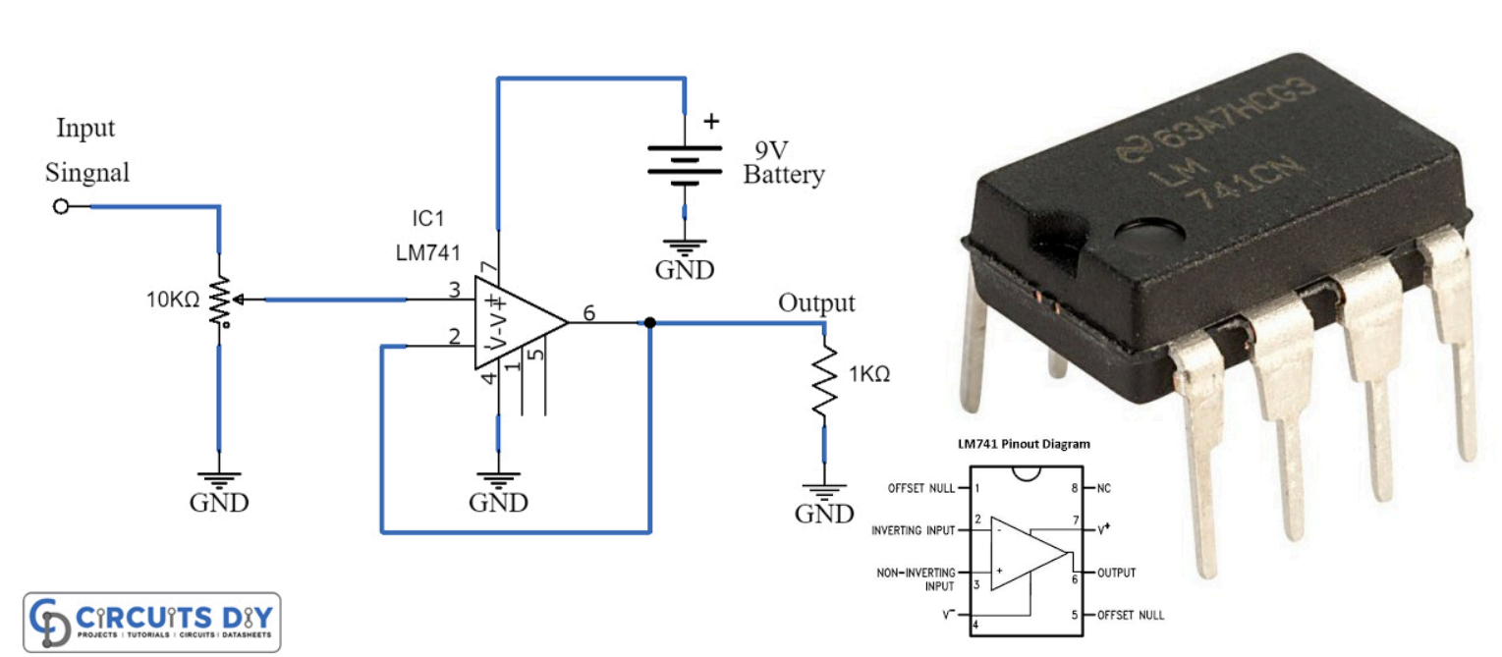

▲ Figure 1. Pin diagram of LM741 Operational Amplifier

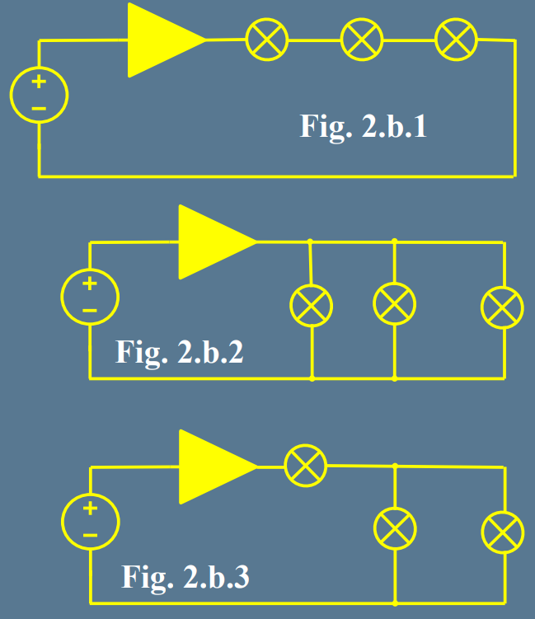

▲ Figure 2. Circuit of Experiment 12.b Different Connections of Light Bulb Circuits

1. Methods

Using Digital Multimeter to observe current and voltage.

1. Experiments data
   1. Experiment 2.a Root Mean Square Measurement

Table 1: Sinusoidal Wave with different offset DC level

|  |  |  |  |
| --- | --- | --- | --- |
|  | Measured | Theoretical | %Err |
| 5V, 1kHz, offset 0V | 3.5581 V | 3.5355 V | 0.64% |
| 5V, 1kHz, offset 1V | 3.5580 V | 3.5355 V | 0.64% |

Table 2: Triangular Wave with different offset DC level

|  |  |  |  |
| --- | --- | --- | --- |
|  | Measured | Theoretical | %Err |
| 3.5V, 2kHz, offset 0V | 2.0432 V | 2.0207 V | 1.11% |
| 3.5V, 2kHz, offset 1V | 2.0431 V | 2.0207 V | 1.11% |

* 1. Experiment 2.b Different Connections of Light Bulb Circuits

Table 3:

|  |  |  |  |  |  |
| --- | --- | --- | --- | --- | --- |
| Circuit | Bulb(#) | Pavg | Vrms | Irms | R |
| 2.b.1 | 1 | 0.5772 mW | 1.0087 V | 0.5722 mA | 1.7628 kΩ |
| 2 | 0.0948 mW | 0.1657 V | 0.5722 mA | 0.2896 kΩ |
| 3 | 0.0878 mW | 0.1534 V | 0.5722 mA | 0.2681 kΩ |
| 2.b.2 | 1 | 0.7387 mW | 3.4439 V | 0.2145 mA | 16.0555 kΩ |
| 2 | 1.6372 mW | 3.4439 V | 0.4754 mA | 7.2442 kΩ |
| 3 | 1.1203 mW | 3.4439 V | 0.3253 mA | 10.5868 kΩ |
| 2.b.3 | 1 | 0.2938 mW | 0.1927 V | 1.5248 mA | 0.1264 kΩ |
| 2 | 0.1094 mW | 0.2005 V | 0.5456 mA | 0.3675 kΩ |
| 3 | 0.0631 mW | 0.2005 V | 0.3145 mA | 0.6375 kΩ |

1. Results

None

1. Discussion

In Experiment 2.b, I measured the unexpected value, but I can’t tell why. Even though I tested the circuit twice, I got the same result as first try.

1. Conclusion

In Experiment 2.a, changing the offset won't affect rms of voltage in both sinusoidal and triangular wave.

In Experiment 2.b, different connection will cause different current and voltage through bulbs.